AA Care Platform

Business Requirements Document

Table of Contents

Document Information 1

Review and Approval 1

INTRODUCTION 2

SYSTEM OVERVIEW 3

SYSTEM REQUIREMENT 4

Consumer Flow 4

Facility Provider/Supervisor Flow 6

AA Administrator Flow 8

Functional use cases on Mobile 8

Functional Use Cases on Web 9

SAMPLE SCREEN DESIGN FOR CONSUMER FLOW 12

PROJECT DELIVERABLES 17

NON-FUNCTIONAL REQUIREMENTS 17

PROPOSED UPGRADES IN PHASE II 18

# Document Information

|  |  |  |  |
| --- | --- | --- | --- |
| Version | Date | Author | Changes since previous version |
| 1.0 | 4.7.2016 | Zalma Jalal | Initial Draft |

# Review and Approval

|  |  |  |
| --- | --- | --- |
| Reviewer Name | Date | Status |
| Tamojit Sengupta | 4.7.2016 | Pending review |

# INTRODUCTION

Background

AA Care Services, hereinafter referred to as AA Care, is an organization focused on the care sector with the mission to promote the health, safety, and quality of life of each person in community care through the administration of an effective collaborative regulatory enforcement system.

AA Senior Care Services, existing platform for AA Care consolidates, owns and manages senior and adult care centres with the provision for other senior care centres to on-board themselves into the platform.

AA Care would like to further this mission by creating a generic care platform where care service providers from various segments can offer their services and will be a one-point stop for consumers to avail variety of care services. The platform would allow care service providers to on-board themselves with a fixed monthly service fee. The platform would act as a generic discovery platform for all care services. The platform would also interact with Government official site to retrieve generic information about all care service providers and their facilities to provide historical information about customer feedback and complaints.

Purpose

This document details the different aspects of the platform (functional scope). The main purpose of this document is to align AA Care’s requirements on building a generic care platform and its goal towards achieving a cross-platform solution, that eases accessibility to innumerable registered facilities across US to the masses.

Document Change Management

Whenever this document this modified, the document history given at the beginning of this document will be updated and this document will be re-circulated amongst all the key stakeholders. This document requires to be updated in the following situations:

* Whenever there is a change of requirement (Change Request).

Intended Audience

This document is prepared mainly for the AA Care team to review the features and to ensure Attinad’s understanding of the solution is in line with AA Care’s requirements. It also acts as the main reference document for AA Care, and describes the expected features and functionalities for the generic care platform. This document must be updated, should AA Care require any changes to the scope of the project.

# SYSTEM OVERVIEW

AA Care is willing to launch a complete care platform which aggregates services from different providers, for the benefit of consumers across US who can search, inspect and block a facility provider within the comfort of their homes or on the go.

The platform will allow consumers to search for any care provider and view its details without any authentication into the system. As part of details for every provider/facility, platform would fetch relevant information from the Government site (ccld.ca.gov). In case the provider is not a registered in the platform, consumers can still view the public information from the government site. For the registered providers, they can add more details about their services, add images and videos, customer reviews and many other information to help consumers decide. Once the consumers decide, they can choose to book an inspection appointment by paying a fixed fee. They can also block a facility for a fixed duration directly from the platform. The platform will be available to users across all major mobile devices and also on web

The platform will allow registered care providers to market themselves in different ways and promote their services. The platform will also provide its own recommendation based on customer reviews and any other mechanism that seem appropriate to AA care administrators.

Based on the earlier discussions by and between AA Care and Attinad, and for the purpose of uniquely identifying functional use cases for different users, the platform will have three key players across the solution: Consumers, Facility Supervisors, AA Care.

All Users will have their own use cases and flows to complete their respective operations. User authentication and authorization will be managed in a secured way and would be done by abstracting the privileges from the user roles. Administrators can define new privileges and add/remove existing privileges from the existing user roles. For consumers, the flow would focus on ease of finding services and a great user experience across mobiles and web. For Providers, registration of their services and necessary operations around managing the content would be the primary activity. For AA Care administrators, the system would provide them with critical information and reports to measure the overall operational effectives and revenue snapshot from the platform. Some of the AA Care admin use cases would be focussing only on web as it may have to deal with high data transaction visualization requirement may be appropriate only for bigger screens.

# SYSTEM REQUIREMENT

This section will define the application flow system requirements for the identified user roles and how the experience would be for the users. The users after their app launch will be taken to the search screen to ensure quick and easy access for finding care services. Users who wish to login and access specific functional modules based on their role can select login option from the menu and enter valid credentials.

## Consumer Flow

* After application launch, Consumer is entitled to avail the search functionality of the app with/without registration or authentication
* User would be taken directly to the search page after splash screen to facilitate quick and easy search. This will maximise the possibility of user transactions
* If the user wishes to login/register, he/she could select the SIGN IN option from the menu. First time users will be directed to the Registration screen, wherein the user enters their personal data. After a validation process, the successfully registered user is directed to the Home page. Registered/returning users will be directed to the Login screen, wherein on successful login, the user is directed to the Home page
* A logged in user can access the following features -
  + Profile screen – to access their personal data
  + My Accounts screen – to access the list of care facilities that are under inspection or booked. Time and contact person information would also be available.
  + Settings screen – to manage privacy, notifications and such other features that will help customize the application for the user’s comfort
  + History screen - to view history of all inspections and bookings.
* In the home screen which is also the search screen will also display recommended facility cares on the top. These could be highest rated service providers or promoted by the platform.
* Consumer, if wants to be very specific of their search and is not getting the desired search result, can select the advanced search results. Advanced search will allow consumers to search based on specific parameters.
* Search results can also be filtered using a filtering option. Basic filter would be generic in nature. However, for logged in users, they can setup their choice of default filter values which will be taken into account while executing search
* Consumer can choose to view the search results on a map which will show the searched facility list on top of the local map on a predetermined zoom level. The consumer would be able to zoom in/out of the map to view facilities as per their interest.
* The maps would include clustering, wherein, a set of facilities listed on a certain area would form a unique cluster with its own custom information. Consumer would be able to tap on these clusters (on a high zoom level), to get the general idea as to the facilities accumulated in that area. Apart from this, a consumer can also view a brief detailed view of individual facility map points as well.
* Consumer has detailed access of the searched care facility information. Apart from the generic data (like Facility Name, Facility Address, Facility Phone, etc.), some care facility details will also include images, videos, etc. as uploaded by the Supervisor for registered service providers
* During the search result, each search item can be identified by their License status and if they are registered facility.
* Once a consumer selects a service, they can choose to opt for inspection of the facility site or block the facility service for a fixed duration. Booking inspection would be charged to the consumer at a fixed value (99 USD per inspection)
* Booking inspections or blocking of service/facility can only be done by a logged in user. In case a guest user clicks on these options, he/she would be redirected to login/register and on successful authentication, would be brought back to the same screen to complete the appointment booking.
* Logged in users will also have the privilege to rate the service provider through textual comments and star ratings which will be processed and will reflect in the overall rating which is shown in the search list screen
* Logged in users can also raise complaints on the services which will directed to the AA Admin to take any action if required.
* Consumer can view their inspection appointments and facility blockings in their accounts screen.
* Consumer can view their history of searches and previously availed services and inspections in their History screen.
* From the history screen, consumer can directly initiate the process to avail the same service again. This would ensure the consumer don’t have to search for an availed service again.
* The search history screen would include only the last 100 number of searches.
* Consumer also has the option to favourite facilities they have searched. This option would be available to them in both detail pages of the facilities and the history screen.

**Flow Chart**

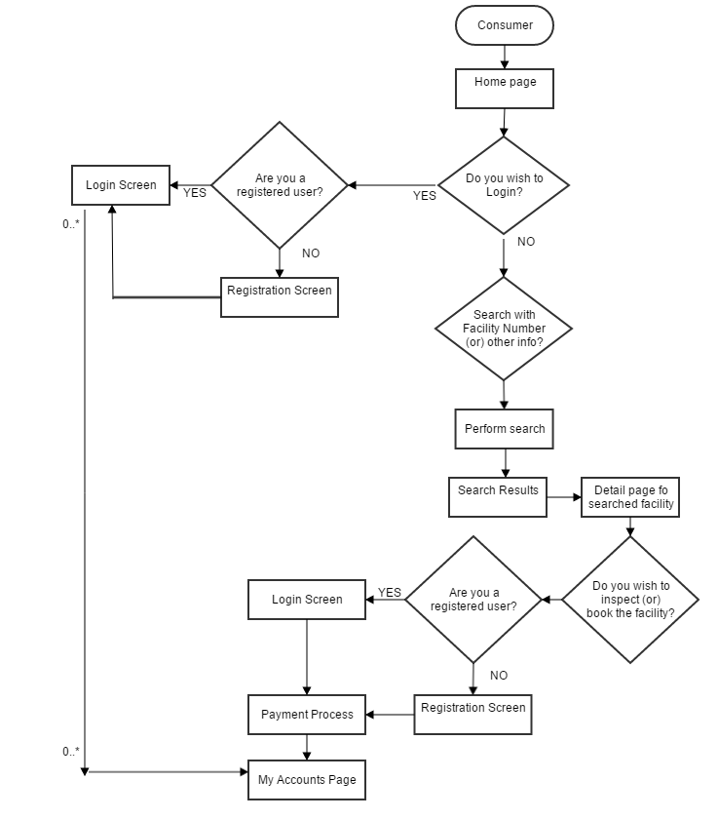

## Facility Provider/Supervisor Flow

* Facility supervisor is admin user responsible for managing a particular care provider in the platform.
* Facility Supervisor is solely responsible for registering a care facility in the platform. To do so, he/she should undergo login/registration process and register as a Facility supervisor.
* Facility registration would undergo User Registration and on successful user registration, user will have to register a facility.
* Facility registration screen will require many mandatory information like Facility number, Type and any uploading of specific license documents which will be available for AA admin to review
* Upon completion of Registration, platform would notify AA admin who will review the information submitted during facility registration process and can approve/reject the facility.
* Based on the action taken by AA admin, notification of approval or rejection would be sent to the facility supervisor user.
* Facility Supervisor can view the status of his registered facilities in the My Facility section. If AA admin approves the registration, the Facility Supervisor will be notified by mail and the status would be shown as APPROVED. If the AA admin rejects the registration, the Facility Supervisor will be notified by mail, the status would be shown as REJECTED along with the details of rejection.
* In case of approved, facility supervisor can login and add more details of the facility and initiate the monthly payment process.
* On subsequent app launch, Facility supervisor can sign in from the home page using the supervisor credentials.
* For first time login as facility supervisor, application will demand adding more information on the facility, uploading images and videos and payment details to complete the profile.
* Facility Supervisor can select either recurring/non-recurring payment method. If a recurring payment is chosen, deduction would be made every month.
* Payment initiation should happen and validated within a week of approval, or else the registration would be cancelled.
* Once profile is completed and payment details are setup. User is taken to the My Facility screen from where he can add/update/remove details about the facility. Number of images and videos that can be submitted should be limited and the upper size of images and videos will also be controlled.
* On subsequent logins, supervisor would be taken to the My Facility screen.
* If a non-recurring payment is chosen, Supervisor would be notified on payment dues through registered email and if the dues are not closed within a specified time, all uploaded contents would be disabled and the facility would be considered an unregistered facility.
* Facility Supervisor can access facility reviews, information, etc through My Facility section as uploaded by consumers.
* Facility supervisors can view appointment requests and the time slot chosen for inspection in my facility section. Notifications on the same will also be sent to the facility supervisor.
* Facility supervisor can opt for promoting his facility in the platform for a fixed duration at an additional cost. Once approved and payment done, facility would be displayed in the featured list in home page for consumers
* Facility supervisor will be shown a dynamic dashboard which will capture the following parameters in the platform –
  + Total registered consumers in the facilities
  + New registered consumers in the facilities in last 1 month or any selected time period
  + Pending/Ongoing inspection details
  + Total blockings by consumers in last one month for all facilities
  + Total revenue from the facilities in last one month
  + Payment dues and other payment related content
  + Approved/Rejected Facility Registration details

**Flow Chart**

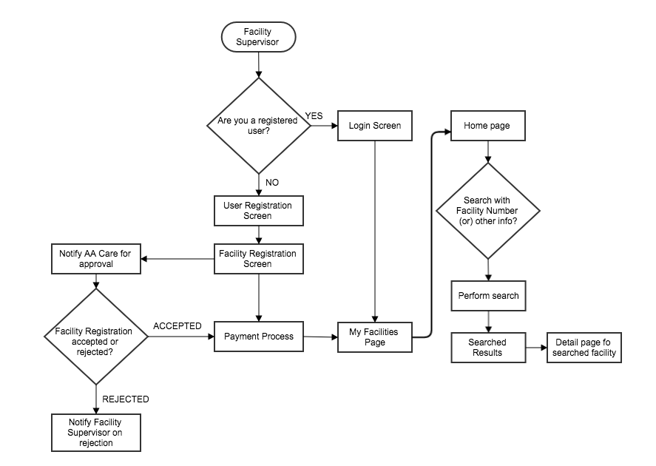

## AA Administrator Flow

* AA Care admin are the platform owners and administrators who will have the privilege to monitor the operations in the platform, view dashboards and reports, take action on facility registration requests and other similar flows where intervention is required.
* Functional use cases for AA admin would be available on both mobiles and web, but mobiles would have a subset of the functional set.

### functional use cases on Mobile

* while login into mobile apps after selecting Sign in from the menu, AA admin would be shown a running dynamic dashboard which will capture the following parameters in the platform –
  + Total registered consumers in the platform
  + New registered consumers in the platform in last 1 month or any selected time period
  + Total care providers registered in the platform
  + New care providers registered in the platform in last 6 months.
  + Total Inspections booked by consumers in last one month
  + Total facility blockings by consumers in last one month
  + Total revenue from the platform in last one month
* Apart from the dashboard mobile apps will also allow AA Admins to view approval/rejection requests and other notifications and take necessary actions. Following requests would be available for the AA admin on mobile
  + Approval/Rejection of Facility registrations
  + List of complaints from consumers
  + List of Facilities who are past their payment due dates.
  + Facilities requesting to be included in the Featured list.

**Flow Chart**

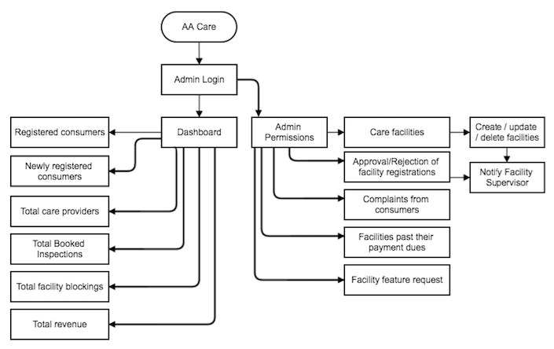

### Functional Use Cases on Web

* On successful login in Web, AA Admin will see a similar running dashboard as defined above in case of mobiles.
* Admin will also have access to approve/reject requests and view notifications for the items mentioned above.
* Apart from the running dashboard, following additional reports would also be available for Admins on web
  + Consumer growth chart on Month to Month basis
  + Facilities and provider growth chart on Month to Month basis and drill down to select a month and view all facilities on boarded that month.
  + Consumer based revenue report
  + Facility based revenue report
  + Region based revenue report
  + Reconciliation report – that lists all the settlements (made in the past / yet to be made) with each registered facility
* View list of all on boarded facility providers and search for a particular facility
* View facility details and review documents submitted during on-boarding process
* View list of all registered consumers and search for a specific consumer and view his/her details
* AA Care admin can update or remove any objectionable content uploaded by the Facility provider.
* AA Care has the authority to remove a care facility without prior notification. Once removed, an email notification would be sent to the Facility Supervisor notifying him/her of the removal

**Flow Chart**

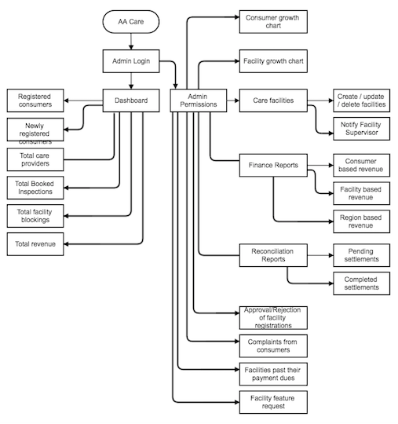

# **SAMPLE SCREEN DESIGN FOR CONSUMER FLOW**

After the application is launched, User is straightaway taken to the home screen where he can start searching for the facilities. Login is not mandatory for accessing the search use cases.

**HOME**

This will be the landing page for all users. In this page, all the featured care facilities are displayed on the top with ratings, thus helping users to identify/select a suitable care facility. There is also a search area with various facility types listed below, wherein, the user can search for their desired care facility.

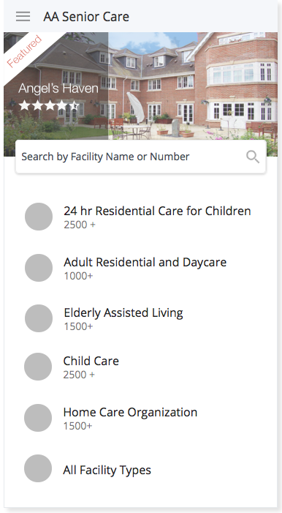

**LOGIN**

From the Home screen, Users who wish to login can do it from the side menu and access functionalities specific to their role or user type. A general consumer is directed to the login/register selection screen when he/she tries to inspect/book a facility from its detail page.

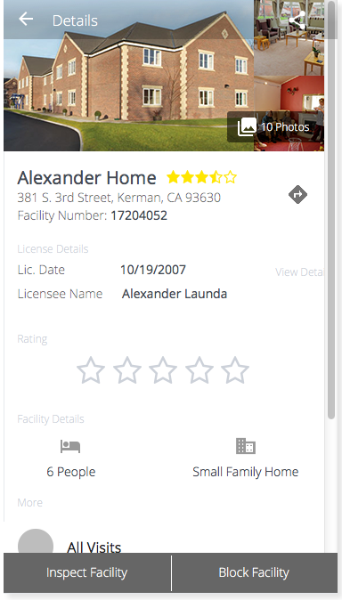 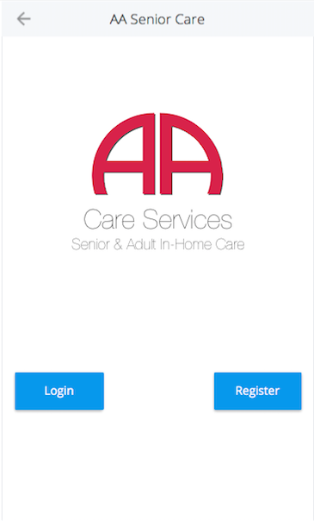

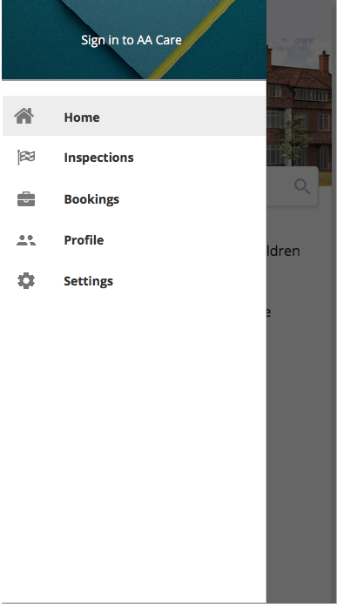 

**SEARCH**

Application will provide a generic search option in the home screen for quick search. Advanced search can be leveraged to filter search results using specific parameters.

**Generic search** is performed using either a Facility Number or a combination of Facility type and Facility Name. Search result can be seen as list or in map where all facilities will be drawn on top of map

 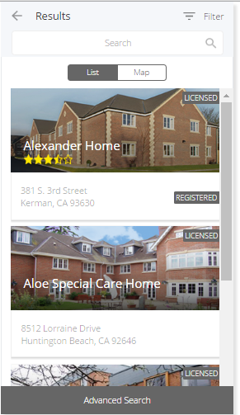

**Advanced search option** is available as a floating button at the bottom of Search results page. This search is performed using Street Name, Zip code, City or County information.

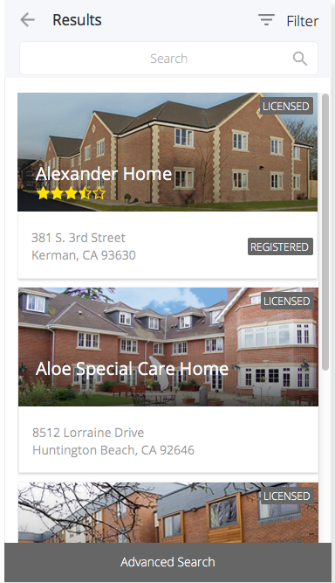 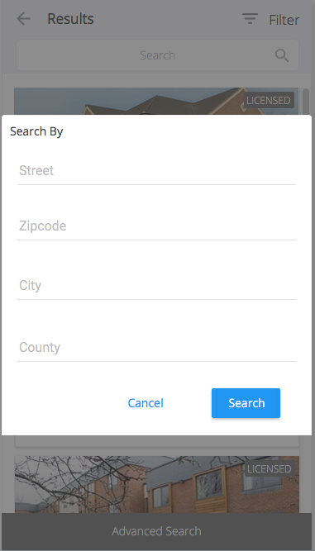

A user can filter the retrieved list of care facilities based on the License and Registration Status.

License Status types are as follows

* All
* Licensed
* Pending
* On Probation

Registration Status types are as follows

* All
* Registered
* Non-Registered

Based on the search criteria, list of facility providers will be shown to users in a responsive way using necessary pagination techniques. From the list, user can select a particular facility and view details. User can book inspection appointments for the facilities and block a care facility if he is comfortable with the available information.

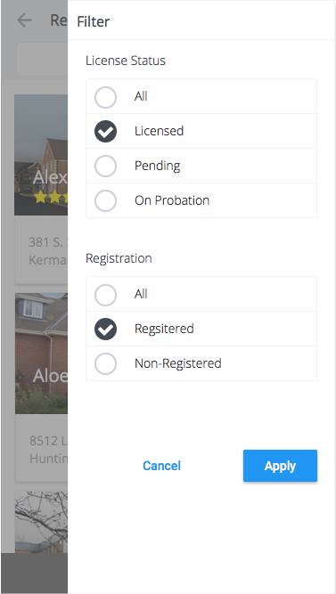 



**INSPECTION AND BLOCKING FACILITY**

Once user views details of a particular facility type and is willing to visit the facility or block the facility, he can do by selecting the right option in the Facility details screen. Both these options are paid services and will take the user to payment screen and will appear in My Accounts section after successful payment



# PROJECT DELIVERABLES

* Software Requirements Specification Document
* Design Document
* Weekly Status Reports
* Software builds and Installation
* Installation and Configuration document
* Test plan
* Test results
* Final source code

# NON-FUNCTIONAL REQUIREMENTS

Platform Coverage

The application shall cover the following mobile platforms for all screen resolutions:

* iOS v8.0, v9.0 and their sub versions (iPhone and iPad)
* Android v4.0, v5.0 and their sub versions
* Web

Language Support

Application should support English language.

Security

Access to the system must be secured and encrypted. Any sensitive data saved locally must be encrypted using industry standard algorithms.

Usability

The system should follow appropriate corporate branding as per Physician Cognition recommendations. The application should enable the users to start using the system with minimum amount of learning. The application should present the users with all expected functionalities in an intuitive and familiar user interface. The application should enable all functionality by keeping the total number of Taps/Gestures/Clicks to the minimum possible. It should be well designed and present similar options on all platforms using existing graphical well known user interface paradigms for the particular platform. The application should have a consistent look and feel across the entire application and across platforms.

Availability

The application should be ensured to be available 24x7. There should be a failover mechanism to address any downtime of server resources.

# PROPOSED UPGRADES IN PHASE II

* Facility Performance report
* Facility Performance vs Feedback report
* Complaint report
* Social Sharing
* Facility Demand based heat map
* Email/Notification based campaign management for driving business